Validation Testing using

TestingWhizz

1. Validation of my form created by me

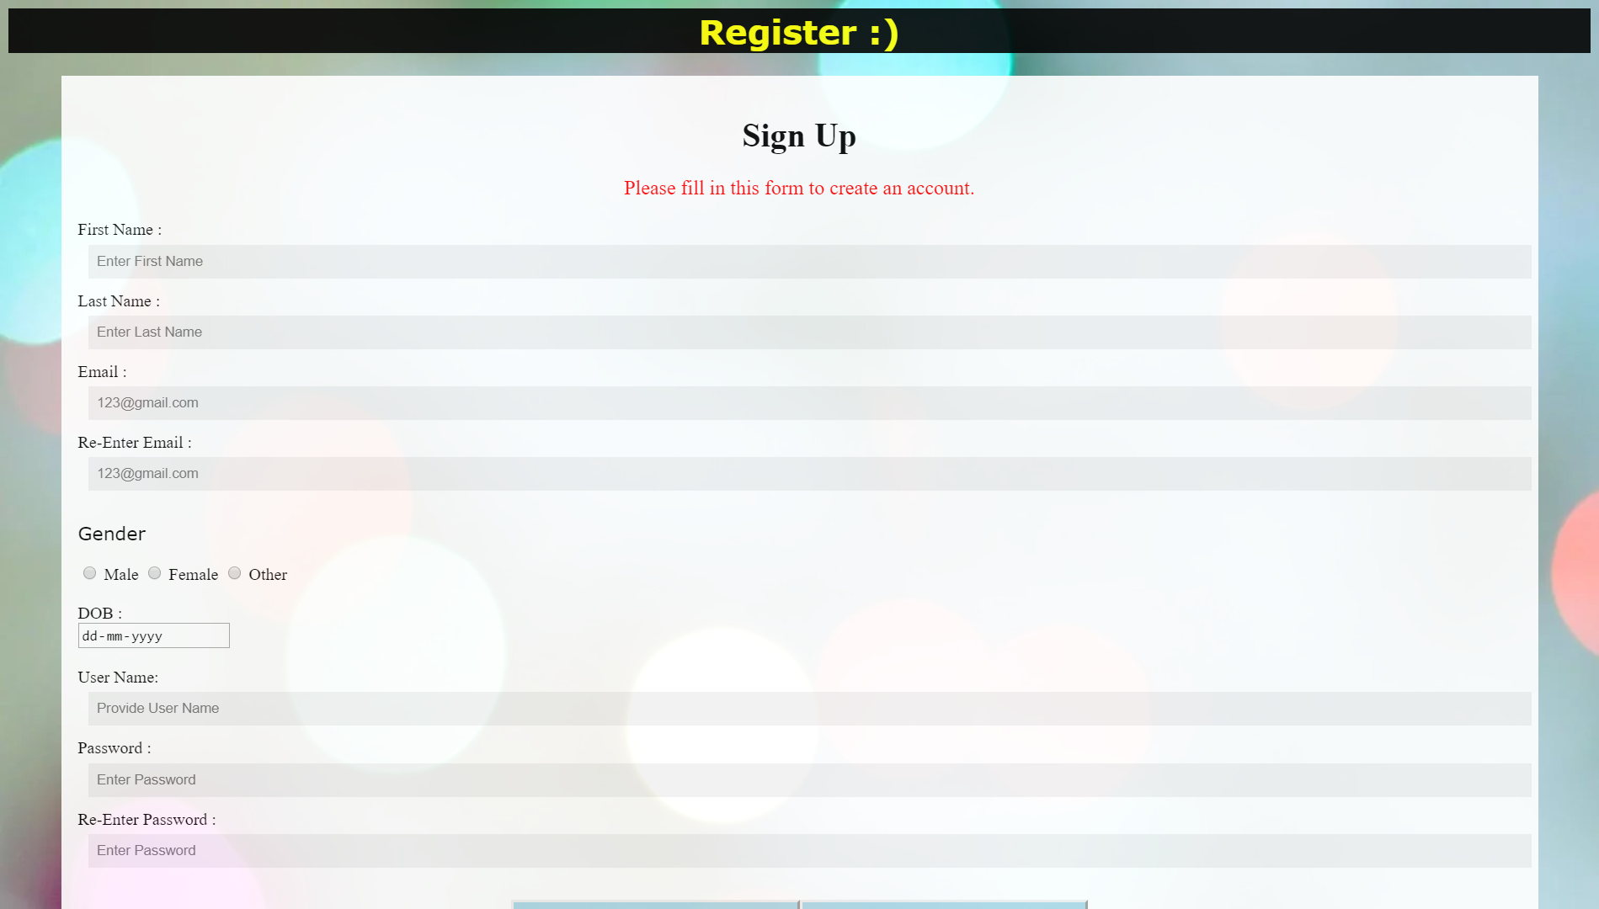

1. Form Code that I created:

<html>

<head>

<title>Forms</title>

<style>

body {

background-image:url('https://images.pexels.com/photos/255379/pexels-photo-255379.jpeg?auto=compress&cs=tinysrgb&dpr=2&h=750&w=1260');

}

#heading{

background-color: black;

color: yellow;

padding: 2px;

text-align: center;

font-family: verdana;

opacity: 0.89;

}

#p2{

font-size: 120%;

color: red;

}

#p1{

font-family: verdana;

font-size: 110%;

}

.frm {

padding: 16px;

background-color: white;

opacity: 0.9;

margin: 1px 50px 1px 50px;

}

input[type=text], input[type=password] {

width: 100%;

padding: 8px;

margin: 5px 10px 12px 10px;

display: inline-block;

border: none;

background: #f1f1f1;

}

#submit{

opacity: 1;

color:green;

background-color: lightblue;

padding: 8px;

width: 20%;

}

#reset{

opacity: 1;

color:green;

background-color: lightblue;

padding: 8px;

width: 20%;

}

</style>

</head>

<body>

<center><h1 id="heading">Register :)</h1></center>

<form>

<div class="frm">

<center>

<h1>Sign Up</h1>

<p id="p2">Please fill in this form to create an account.</p></center>

<label for="fname">First Name :</label><br>

<input type="text" placeholder="Enter First Name" id="fname" name="fname"><br>

<lable for="lname">Last Name :</lable><br>

<input type="text" placeholder="Enter Last Name" id="lname" name="lname"><br>

<label for="mail">Email :</label><br>

<input type="text" placeholder="123@gmail.com" id="mail" name="mail"><br>

<label for="mail">Re-Enter Email :</label><br>

<input type="text" placeholder="123@gmail.com" id="mail" name="mail"><br>

<p id="p1">Gender</p>

<input type="radio" id="male" name="gender" value="male">

<label for="male">Male</label>

<input type="radio" id="female" name="gender" value="female">

<label for="female">Female</label>

<input type="radio" id="other" name="gender" value="other">

<label for="other">Other</label><br><br>

<label for="birthday">DOB :</label><br>

<input type="date" id="birthday" name="birthday"><br><br>

<lable for="uname">User Name:</lable><br>

<input type="text" placeholder="Provide User Name" id="uname" name="uname"><br>

<label for="pass">Password :</label><br>

<input type="password" placeholder="Enter Password" id=""pass" name="pass"><br>

<label for="pass">Re-Enter Password :</label><br>

<input type="password" placeholder="Enter Password" id=""pass" name="pass"><br><br>

<center><button type="submit" id="submit">Sign Up</button><button type="reset" id="reset">Reset</button><center>

</div>

</form>

</body>

</html>

1. Recording The Form

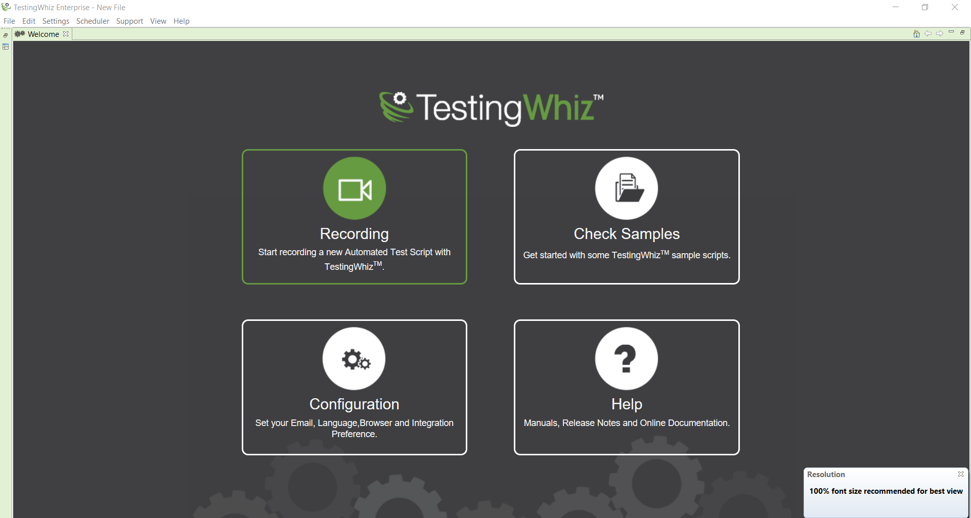

1. Now opening form in testingwhiz

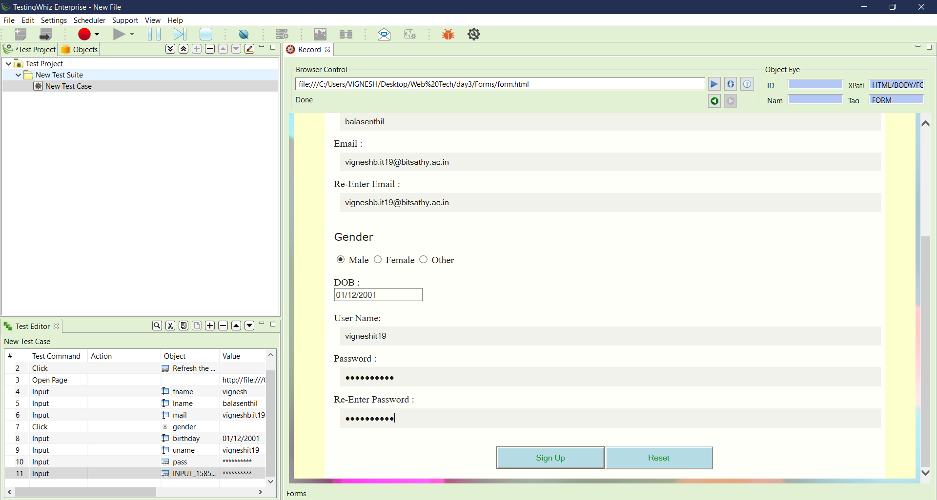

1. All the inputs are recorded

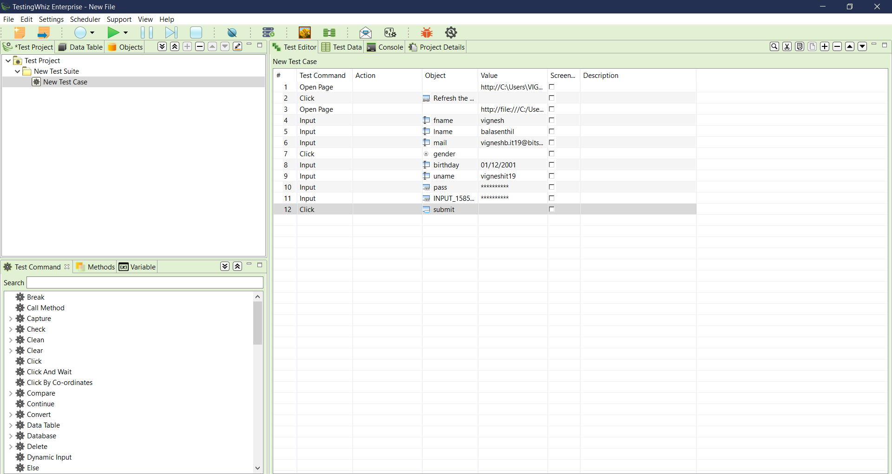

1. Adding Test command to test my form

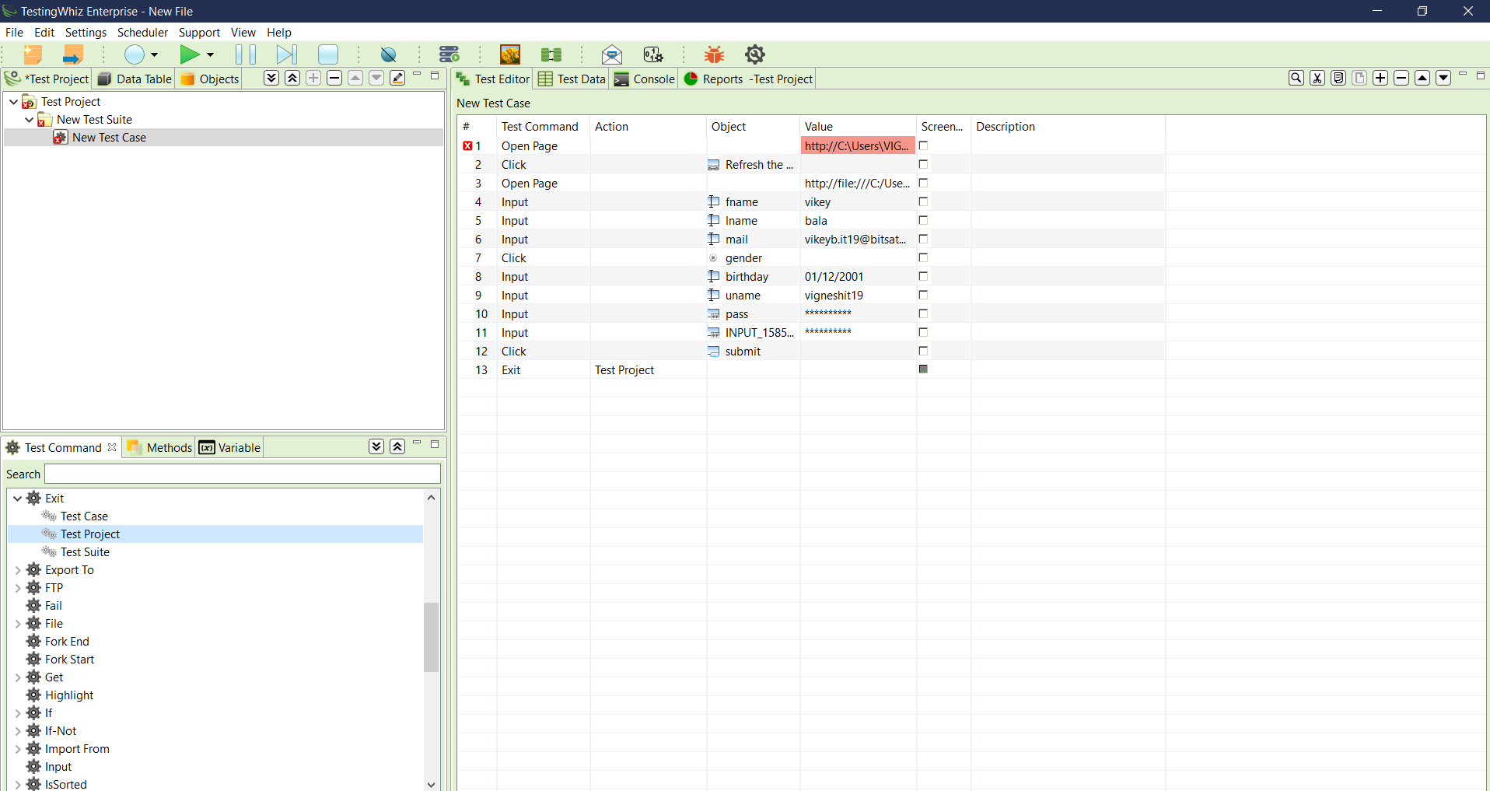

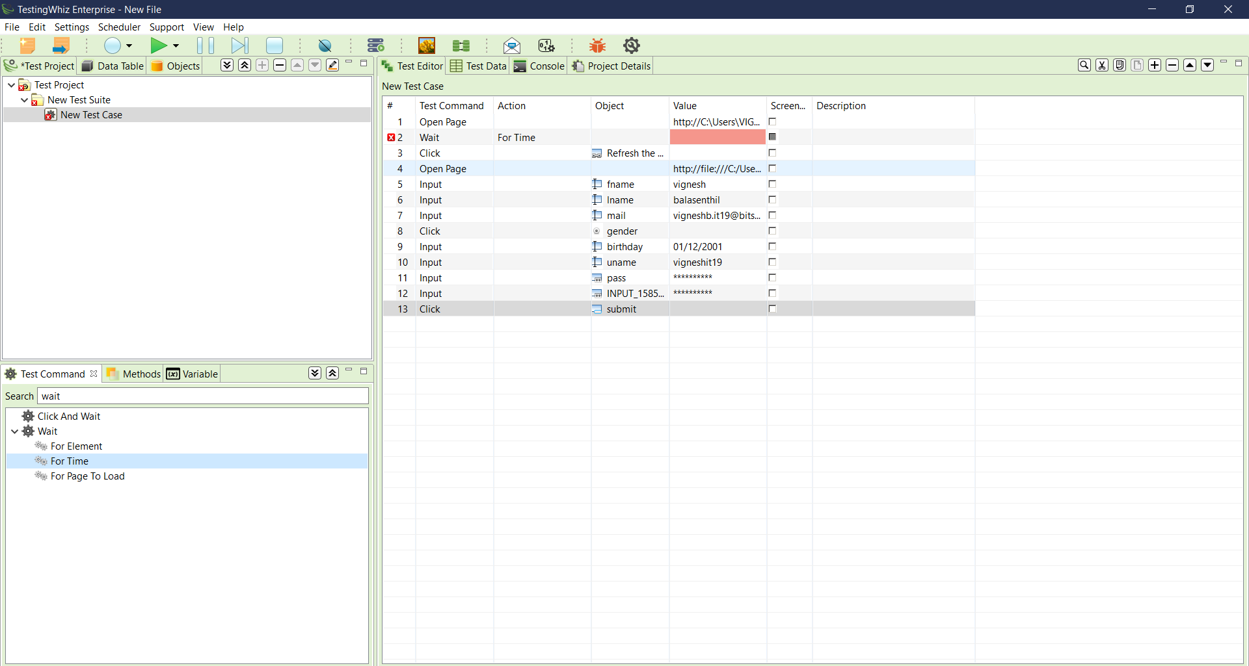

1. Test report is obtained below

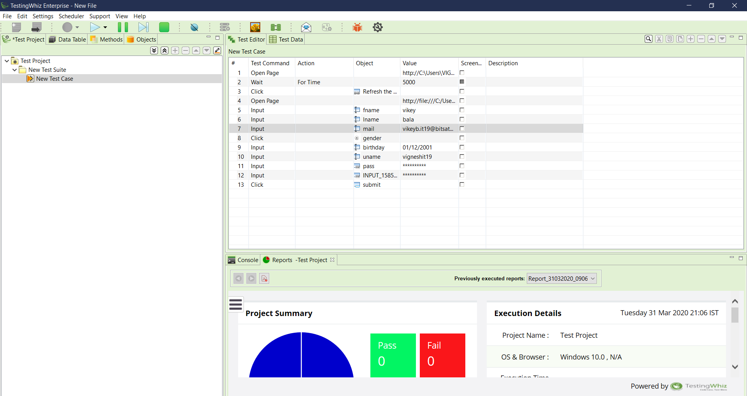

# Tools Used

# TestingWhiz



Created by

* B.Vignesh
* 192IT254
* Information Technology
* I year II semester(Even)

--------------------------------------------------------------------------------------------------------------------------------------